Q Count occurrence of letter ‘A’ with Big O(1)
Input
String[] arr = { "A", "B", "C", "D", "E", "F", "F", "G", "A" };

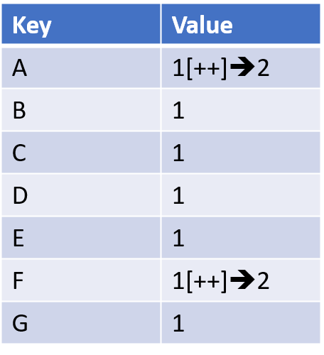
import java.util.HashMap;

public class Demo2 {
public static void main(String[] args) {
// Input array
String[] arr = { "A", "B", "C", "D", "E", "F", "F", "G", "A" };

// Step 1: Build frequency map (O(n))
HashMap<String, Integer> freqMap = new HashMap<>();
for (String item : arr) {
// If key found then increment its value
if (freqMap.containsKey(item)) {
freqMap.put(item, freqMap.get(item) + 1); // If already present, increment
} else {
freqMap.put(item, 1); // If not present, add with count 1
}
}
// Step 2: Query in O(1)
System.out.println("Count of A: " + freqMap.get("A"));
}
}

A | 2
B | 1
C | 1
D | 1
E | 1
F | 2
G | 1

